A STOCK COMPANY

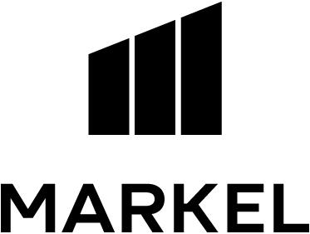

MARKEL INSURANCE COMPANY
10275 West Higgins Road, Suite 750
Rosemont, IL 60018

INSURANCE POLICY

Coverage afforded by this policy is provided by the Company (Insurer) and named in the Declarations.

In Witness Whereof, the company (insurer) has caused this policy to be executed and attested and countersigned by a duly authorized representative of the company (insurer) identified in the Declarations.

 | 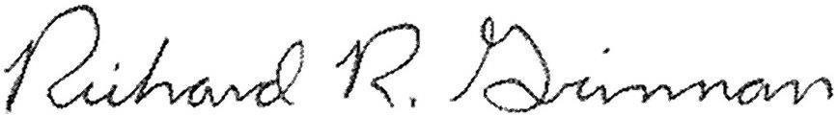 |  |  | 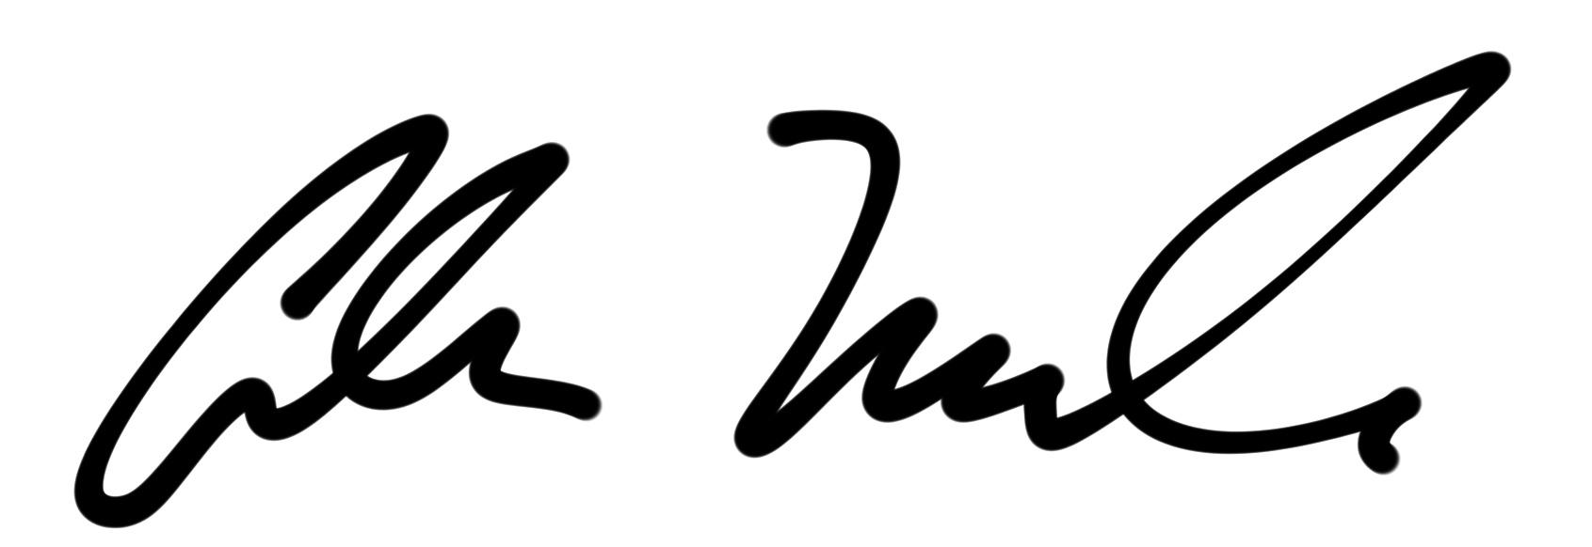
 | Secretary | President

