MARKEL INSURANCE COMPANY


COMMON POLICY DECLARATIONS

POLICY NUMBER: Number | RENEWAL OF POLICY: Renewal of Policy

Named Insured and Mailing Address (No., Street, Town or City, County, State, Zip Code)
Testing
Test DBA Name
Address Line 1
Address Line 2
City, State Zip
Policy Period: From 05/31/1999 to 05/31/1999 at 12:01 A.M. Standard Time at your mailing address shown above.
BUSINESS DESCRIPTION: Business Description
FORM OF BUSINESS
 | Individual |  | Partnership |  | Joint Venture |  | Trust |  | Corporation
 | Limited Liability Company |  |  |  | Other Organization: | Other Organization
Audit Period: Annual unless otherwise stated: |  |  |  |  |  | FTZ Code: NYFTZ Code NYFTZ Description

IN RETURN FOR THE PAYMENT OF THE PREMIUM, AND SUBJECT TO ALL THE TERMS OF THIS POLICY, WE AGREE WITH YOU TO PROVIDE THE INSURANCE AS STATED IN THIS POLICY.
THIS POLICY CONSISTS OF THE FOLLOWING COVERAGE PART(S), BUT ONLY FOR WHICH A PREMIUM IS INDICATED. THIS PREMIUM MAY BE SUBJECT TO ADJUSTMENT.
 | Commercial Property Coverage Part |  |  |  | Not Covered
 | Commercial General Liability Coverage Part |  |  | $ | 1.1
 | Commercial Inland Marine Coverage Part |  |  |  | Not Covered
 | Commercial Ocean Marine Coverage Part |  |  |  | Not Covered
 | Commercial Professional Liability Coverage Part |  |  |  | Not Covered
 | Commercial Automobile Liability Coverage Part |  |  |  | Not Covered
 | Liquor Liability Coverage Part |  |  |  | Included
 | Crime Coverage Part |  |  |  | Not Covered
 | Other Coverages: | Employee Benefits Liability |  |  | Included
 |  | Premium Total |  | $ | 1.1
 | Other Charges:
 |  | Inspection Fee |  | $ | 1.1
 |  | Other Fee |  | $ | 1.1
 |  | Policy Fee |  | $ | 2
 |  | TRIA Premium |  | $ | 1.10
 |  | GRAND TOTAL |  | $ | 1.1
Producer Number, Name and Mailing Address
Number
Agent Company Name
Address Line 1 |  |  | Inspection Ordered: Yes No
City, State Zip |  |  | Program Code:

Endorsements
Forms and Endorsements applying to this Coverage Part and made part of this policy at time of issue:
SEE FORMS SCHEDULE - MDIL 1001

These declarations, together with the Common Policy Conditions and Coverage Form(s) and any Endorsement(s), complete the above numbered policy.

Countersigned: | 07/30/2026 | By: | 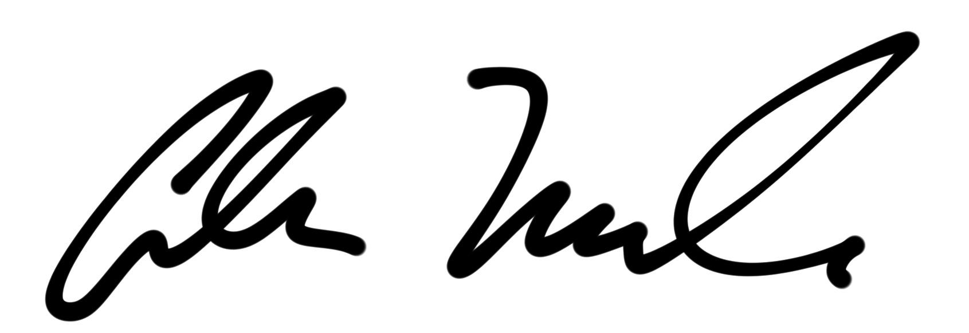
 | Date |  | AUTHORIZED REPRESENTATIVE

